NATURE RESEARCH CENTRE
DIRECTOR

ORDER
ON SETTING THE AMOUNT OF FUNDS TO ENSURE RESEARCH AND MOBILITY OF DOCTORAL STUDENTS STUDYING IN STATE-FUNDED DOCTORAL STUDY POSITIONS

25 January 2023, No V-10

Vilnius

Acting in accordance with the Resolution No 149 of the Government of the Republic of Lithuania of 1 March 2017 "On the Implementation of the Law on Higher Education and Research of the Republic of Lithuania",

I hereby set the amount of funds to ensure research and mobility of doctoral students studying in state-funded doctoral study positions in the first–fourth year of doctoral studies shall be EUR 900 (nine hundred euro) in the study year 2023.

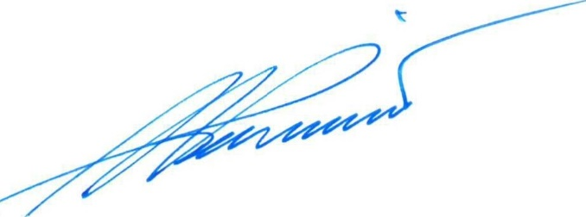

Director Sigitas Podėnas

